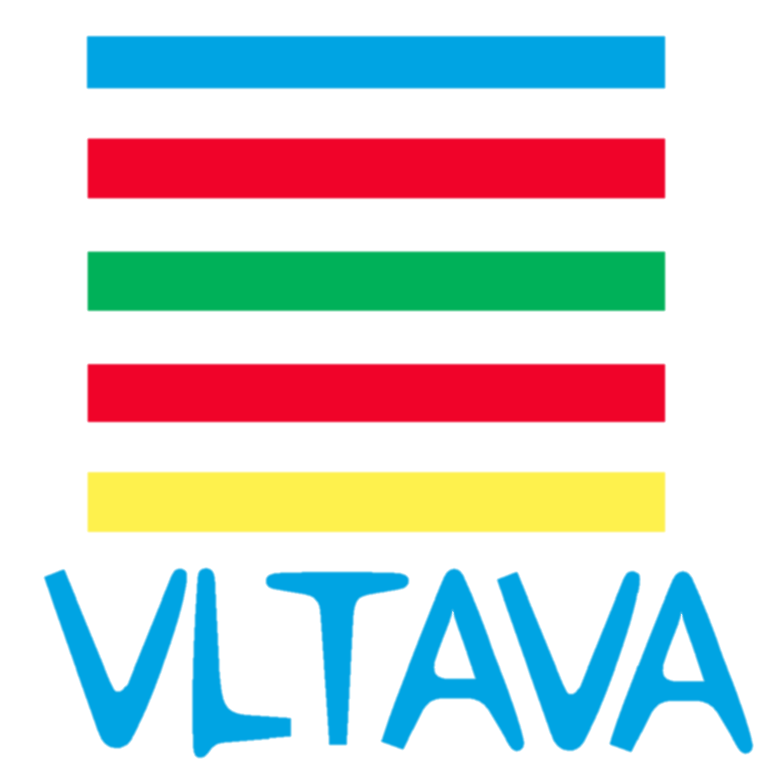
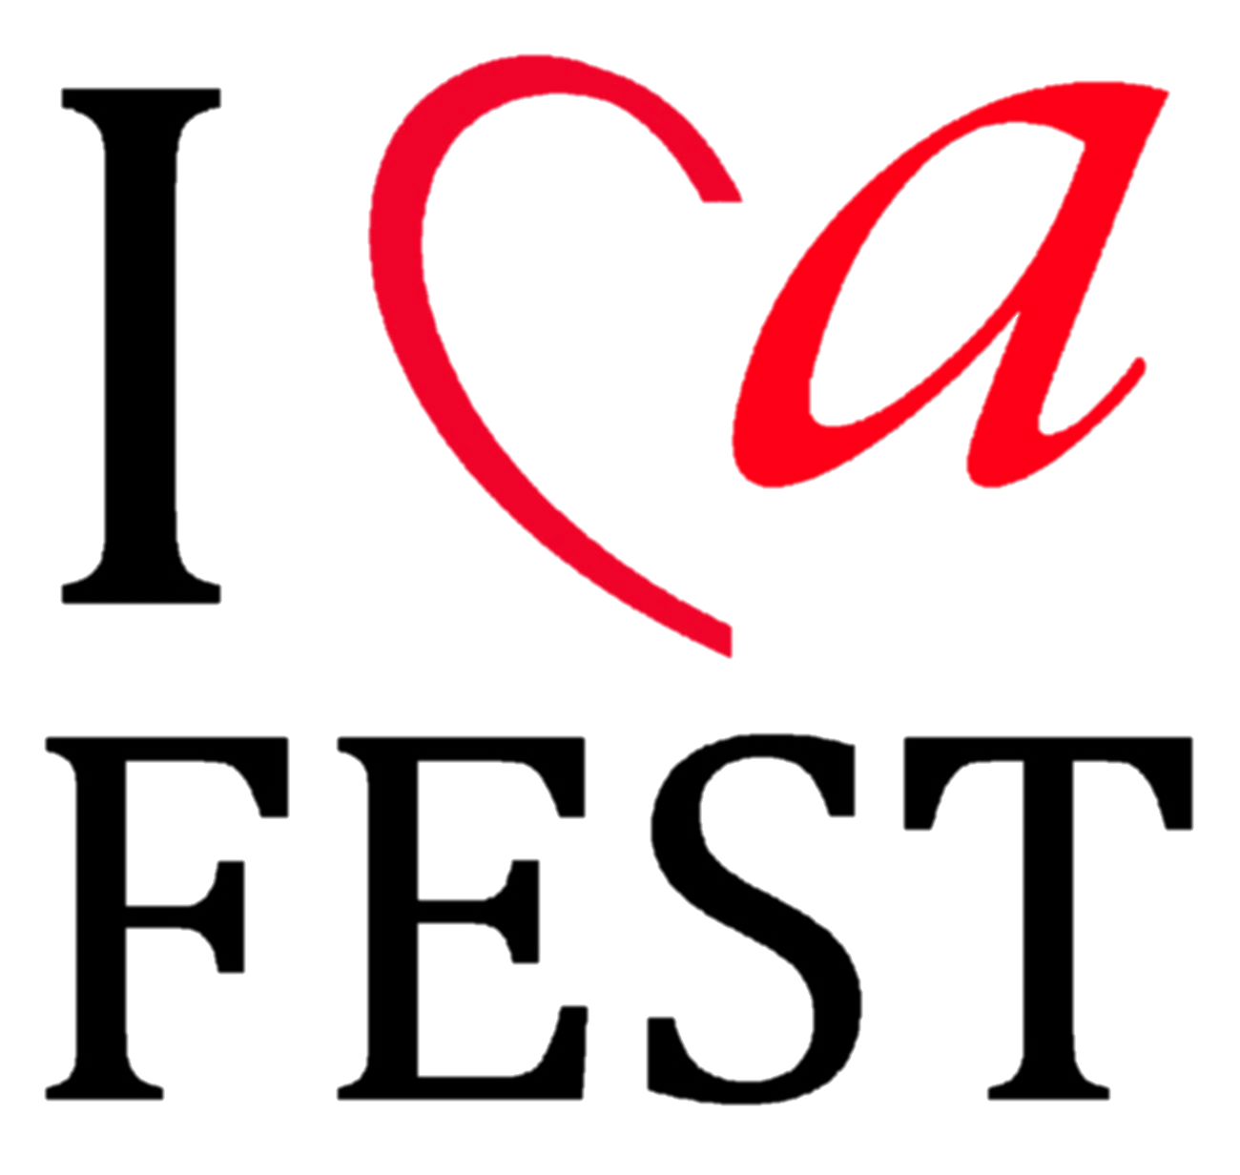

Application Form 管乐比赛报名表
Basic Info 基本信息
Name of the group团队名称
Performing Numbers of the groups 团队参加演出的人数
Total numbers of the group团队人数
Age range of the performing member except conductor
参加演出的年龄段区间（不包括指挥）
City original of the group来自哪个城市
Country original of the group来自哪个国家
Performance category参加项目 |  |  | Brass管乐 |  |  |  |  | Other其他
Category 参加组别
Children up to 15 years old/15岁以下儿童管乐团
Youth up to 22 years old／22岁以下青少年管乐团
Open Age Category／开放年龄爱好者管乐团
Free style music group／其他形式乐队或乐团
Equipment Support 基本配备（更多详见乐器单）
Number of Chairs需要座椅数量 |  |  |  | Number of Music Stand谱架数量
Other demands其他（请参照乐器单）

Contact 联系
Contact Person of the group团队联系人
Contact Email联系邮箱
Contact Address 联系地址
Contact Number联系号码
Attaching Document 附件材料
Till 15.11.2015 send the application form please, and
Till 30.12.2015, send the following documents please:
- Program list with Author of Music and time duration 演出节目单，请注明作者和节目时长
- 1 copy of notation 1份乐谱（扫描件）
3) Brief Introduction of your group 团队简介（300字以内）
4) 1-2 Photo, within 2 years new 2年内的团队照片1－2张（jpg格式）
Organizer Contact组委会报名联系人：张姝、杨敏、Katerina Markelova
Email邮箱：icafest@gmail.com
Phone Number电话：0086 134 8878 0986、0086 136 0308 0746、00420724234172
请到www.icafest.com下载或者联系工作人员获取电子版报名表。

