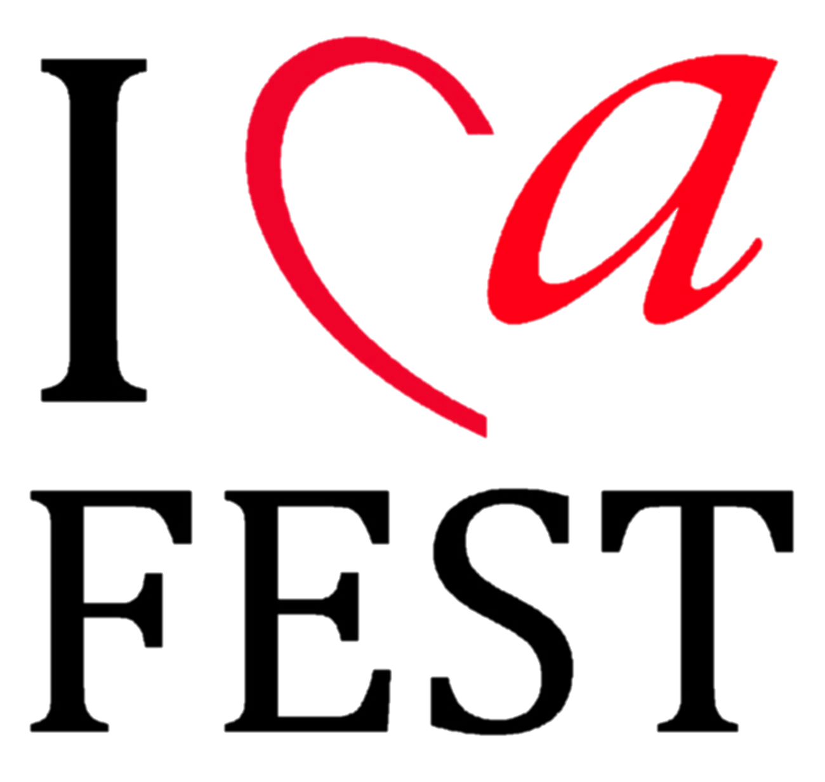

Application Form 合唱比赛报名表

Basic Info 基本信息
Name of the group团队名称
Performing Numbers of the groups 团队参加演出的人数
Total numbers of the group团队人数
Age range of the performing member except conductor
参加演出的年龄段区间（不包括指挥）
City original of the group来自哪个城市
Country original of the group来自哪个国家
Performance Type表演形式 |  | Choir合唱 |  |  |  |  | Other其他
Category 参加组别
Each Choir can choose max. 2 categories 每个团队最多选择2个组别
B | Teen’s choirs up to 16 years Mix/ 16岁以下少年混声
C | Youth Choirs up to 22 years Mix/ 22岁以下青年混声
D | Adult Choirs Mix／成人组混声
E | Small group Choir up to 10members／10人以下小组合唱
F | Folk songs／民歌作品组
T | Free Style performance／Friendship Concert  自由表演/友好音乐会
Contact 联系
Contact Person of the group 团队联系人
Contact Email联系邮箱
Contact Address联系地址
Contact Number联系号码

Attaching Document 附件材料
Till 15.11.2015 send the application form please, and
Till 30.12.2015, send the following documents please:
- Program list with Author of Music and time duration 演出节目单，请注明作者和节目时长
- 1 copy of notation 1份乐谱（扫描件）
3) Brief Introduction of your group 团队简介（300字以内）
4) 1-2 Photo, within 2 years new 2年内的团队照片1－2张（jpg格式）
Organizer Contact组委会报名联系人：张姝、杨敏
Email邮箱：icafest@gmail.com
Phone Number电话：0086 134 8878 0986、0086 136 0308 0746,00420 724 234 172
请到www.icafest.com下载或者联系工作人员获取电子版报名表。

